STAT 5120

Homework1

Yunlu Li

Question 1

(a) A simple linear regression appears reasonable for the data.

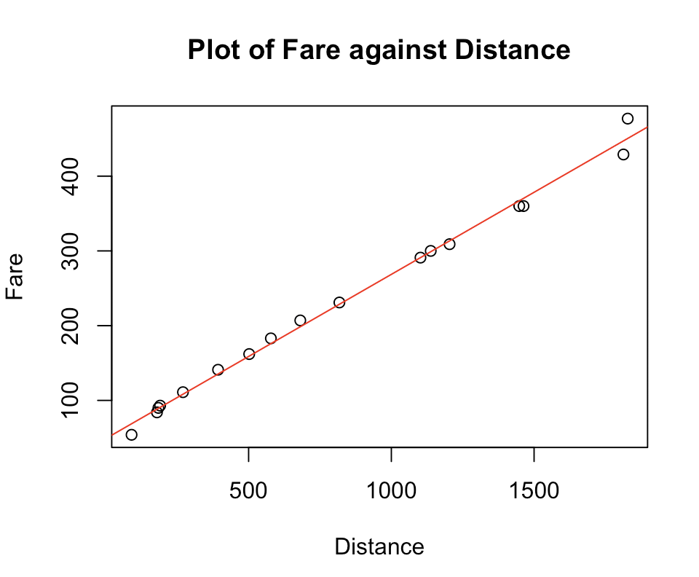

(b) Estimated slope = 0.2197. The average fare would increase by 0.2197 for each additional unit of distance.

Estimated intercept = 48.9718. The fare is expected to be 48.9718 when traveling 0 distance.

The regression equation is $y=48.9718+0.2197x$

(c) The value of R^2 is 0.994. It means 99.4% of fare can be explained by the predictor (distance).

(d) The correlation is 0.9969765.

(e) The estimated value for the variance of the error terms is 10.41^2.